JOHNNY ROPER -- CASE NUMBER: 7-13-TR-XXXXX

Note: Due to the formal nature of these proceedings; Johnny will be utilizing Illeism [go to: http://en.wikipedia.org/wiki/Illeism] by referring to himself in this document with third person singular status as "John".

John is respectfully asking the court to dismiss this infraction due to: 1) the lack of Johns' ability to see the posted 40 MPH sign on Blossom Hill Road (see photo below); 2) Johns' relatively clean driving record (not receiving a speeding ticket for about 3 decades; and working as a distribution driver during much of that time); 3) Johns' extensive traffic calming efforts in his own neighborhood (see photos on pages 5-9 below); 4) Johns' volunteer efforts in his neighborhood (3 hours per week for the last 10 years; equaling approximately 1500 community service hours already served); and 5) lack of monetary funds at this particular moment; And if this is not possible; due to his financial situation John asks that at very least his fine be reduced and he be assigned to traffic school instead. Other things to consider:

1) Blossom Hill Road signage covered up by bushes: This photo clearly shows the 40 MPH sign on Blossom Hill Road hidden from sight at the top of the overpass.

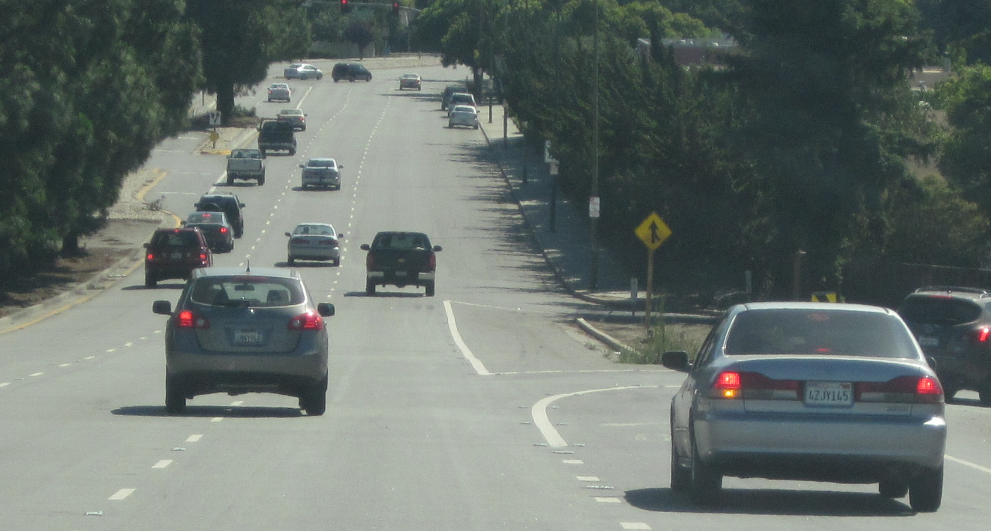

2) Speed Trap – bottom of a hill and/or overpass: SJPD Officers were waiting at the bottom of this hill just past the hidden 40 MPH sign; using gravity as an advantage to catch speeders who naturally speed at the bottom of a steep grade. Adding to this; John has worked with City of Santa Clara traffic engineers regarding traffic and speeding issues within his own neighborhood. These traffic engineers have said that most MPH signs are set at about 10 miles per hour under the expected speed limit; because traffic engineers know that most people do not drive the actual speed limit.

Therefore; at 54 MPH John was only doing only about 4 MPH over the expected speed limit; and at approximately $300 dollars for the ticket; this amounts to roughly $130 dollars per mile per hour over that expected speed limit; and this seems highly unfair to John.

NOTE: John thinks you should charge people no more than $100 per 10 MPH over the posted speed limit; then make up for any lost revenues by allowing people to choose their license photo at the DMV for an extra $5 or $10.

3) John was stopped way too fast -- This particular traffic stop utilized a new method where SJPD stood on the side of the road with a camera-like device; recording the speed of drivers on Blossom Hill Road.

This new method caused John's vehicle to stop so rapidly that the contents of his vehicle shifted forward in a dangerous fashion. This could actually do more harm than good in the case of an accident stemming from such a practice. One month after receiving the ticket; John passed through the very same intersection and witnessed an accident that had just taken place on the opposite side of the road.

> John believes that this stretch of road definitely needs extra attention when it comes to traffic calming. But! this particular problem has come about largely due to poor planning on the part of the agencies who designed this roadway to begin with. (see mercurynews.com link below and/or go to: http://www.mercurynews.com/troy-wolverton/ci_24302684/wolverton-apples-spaceship-is-landing-wrong-place)

Essentially; exits from both Monterey Road and Highway 101 introduce a high volume of traffic directly onto the same stretch of road where John got his ticket.

And while this stretch of road was once a relatively slow moving semi-residential road many years ago; it has slowly been transformed into a semi-expressway due to the vehicles exiting Monterey Road and Highway 101 at such a very high rate of speed. Therefore; John believes that permanent traffic calming solutions need to be brought to this stretch of Blossom Hill Road; as well as many other stretches of road in the Santa Clara Valley needing similar permanent changes.

4) Police Officer Conduct -- SJPD Officer Farias was very courteous during Johns' traffic stop; offering him advice on how to go about taking care of this ticket.

5) Short-term and long-term reasons for lack of money:

A) Long-term reason for lack of funds: http://likroper.com/CIVILRIGHTSX.html -- Note: John has submitted two claim files to the City of Sunnyvale; with no action taken as of yet to correct this situation + B) Short term reason for lack of funds: Recent cutbacks to Johns' delivery route have caused him to lose approximately 1/3 of his monthly pay.

6) AS PROMISED? / Dunford Way Signage: Permanent Traffic Calming solutions needed (all over the Santa Clara valley) -- Back in the late 1990s; Johns' efforts led to a neighborhood meeting at the old Santa Clara Library. At this particular meeting; many traffic calming changes were promised to Johns' neighborhood by the City of Santa Clara; but none of these original promises have ever been kept .

Books were handed out to all the neighbors showing the various ways traffic engineers can slow traffic in Johns' neighborhood; BUT NONE OF THESE METHODS WERE EVER UTILIZED. All the City ended up installing was one lousy chevron sign. (see photos below -- all other signage see in these photos was installed BEFORE the neighborhood meeting at the library as a result of Johns' efforts)

QUESTION: Could this perhaps be due in part to the excessive profitability of ticket writing?

Here's California's 2009 breakdown (because it is all John could find online): Effective 01/01/2009: Total fines for traffic violations may be calculated as follows: Base Fine set by legislation and the Judicial Council of California. Penalty Assessment: Penalty assessments are allocated for such items as court and jail facility construction and other items as noted below:
$10.00 per $10/base fine per PC 1464 goes 70% to State Trial Court Trust Fund; 30% to County General Fund / $2.00 per $10/base fine per GC 76100 goes to the County Courthouse Construction Fund / $2.50 per $10/base fine per GC 76101 goes to the County Jail Construction Fund / $0.50 per $10/base fine per GC 76102 goes to County Automated Fingerprint Fund / $2.00 per $10/base fine per GC 76104 goes to Maddy Emergency Medical Fund (State/County split) / $3.00 per $10/base fine per GC 70372.(a) goes to State Court Facilities Construction Fund / $1.00 per $10/base fine per GC 76104.6 goes to the DNA Identification Fund (County/State split) / $1.00 per $10/base fine per GC 76104.7 goes to the DNA Identification Fund (County/State split) / $2.00 per $10/base fine per GC 70372(a) goes to the State Court Facilities Construction Fund -

Immediate and Critical Needs Account / Night Court Assessment Fee pursuant to VC 42006 / DMV record fee pursuant to Vehicle Code 40508.6 / Twenty percent criminal surcharge pursuant to Penal Code 1465.7 / Court Security Fee pursuant to Penal Code 1465.8 / Criminal Conviction Assessment pursuant to GC 70373 goes to the State Court Facilities Construction Fund - Immediate and Critical Needs Account (assessed per conviction)

NOTE: In light of these facts; government has little or no incentive to bring EFFECTIVE; PERMANENT changes to the traffic infrastructure due to the profitability of inaction. This is apparently not a competency hearing regarding John; but instead a government competency hearing; as BIG CHANGES are needed to increase traffic safety.

John has seen Santa Clara and Sunnyvale traffic engineers go around in circles in his own neighborhood; putting up traffic counters on the roadway; with no real changes ever implemented. And giving out speeding tickets is essentially the same thing; it does nothing to solve the underlying systemic problem; it merely puts a bandaid on a festering wound.

Johns' big brother Carl Clefstad was killed in a head-on collision on highway 152 on Christmas eve 1999. The driver who killed Carl (Danny Matos) had been allegedly let go while speeding by a Sunnyvale Police Officer a few weeks before this in early December 1999; allowing Danny to slam into Carls' Volkswagen bus at 80 MPH. Carl died instantly.

And! this came after years of action on Johns' part trying to get the local cities to do something about the out of control speeding that was going on in and around his neighborhood during the go-go 1990s. This shows a gross negligence on the part of local agencies when it comes to following up on promises made and/or protecting lives.

There have been approximately 10 recorded Accidents on Johns' property over time due to the placement of Johns' house in relation to the curve in the road he lives near; and this is what largely drove John to seek necessary changes through the Cities of Sunnyvale and Santa Clara.

But even after a previously mentioned late 1990s neighborhood traffic calming meeting where the City of Santa Clara made various promises; it was a major hassle for John to get even one chevron sign installed to remind drivers of the dangerous curve in the road.

7) STATE LAW CROSSWALK SIGNS NEEDED NOW! @ http://www.youtube.com/watch?v=CEw0U15oaMQ

This You Tube video is a good (and/or bad) example of insufficient traffic calming efforts here in the Santa Clara Valley. This video has been posted for about 4 years now with no action taken to correct the dangerous situation in Johns' neighborhood.

> SEE ALSO: http://likroper.com/2012_09_28_0804AM.wmv

8) TV Commercials: Guns and Cars -- Cigarettes were long ago banned from TV advertising; just like hard alcohol and guns; because they are truly dangerous products. So why is it still legal for automobile manufacturers to run ads showing people driving around like maniacs? As long as this kind of advertising is still legal; it will continue to cause unsafe driving.

EXCERPTS FROM THE SAN JOSE MERCURY NEWS (This is an example of poor planning going on at this moment near Johns' residence): -- Troy Wolverton:

Apple's spaceship is landing in the wrong place: Apple's new campus is going to be a traffic nightmare that offers little benefit to the surrounding community. Instead of being a symbol for Silicon Valley, it will be emblematic of urban planning gone way wrong.

Whatever the project's architectural merits, the spaceship building is going to be huge. At 2.8 million square feet, it will be one of the largest buildings in the country, more capacious even than the Empire State Building and more than five times larger than the Transamerica Pyramid.

Apple says the spaceship's actual footprint will be smaller than the existing buildings on the site, because its floor space will be spread across four stories. But there will be more to the campus than just the spaceship. Add up the buildings that will house the corporate fitness center, the parking garage and an auditorium, and you get nearly 6 million square feet of space, which is within spitting distance of the size of the Pentagon.
That size may be appropriate for a downtown metropolis or a rural setting with little else around it, but it doesn't belong smack dab in the middle of single-family homes and strip malls. Would you want the Empire State Building or the Pentagon in your backyard?

The new campus will accommodate 14,200 workers, some 12,000 in the spaceship alone. That's nearly three times the number of people who currently work in buildings on the 176-acre site. Is it any wonder that the environmental report commissioned by the city of Cupertino expects widespread and severe traffic problems around the proposed site?

READ MORE @ http://www.mercurynews.com/troy-wolverton/ci_24302684/wolverton-apples-spaceship-is-landing-wrong-place

ALL THE STREET SIGNS SEEN BELOW WERE PLACED DUE TO JOHNS' EFFORTS:
(SCROLL DOWN)

1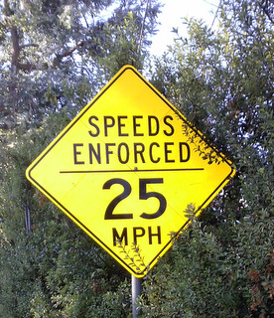
Speeds are NOT being regularly enforced on Dunford Way…
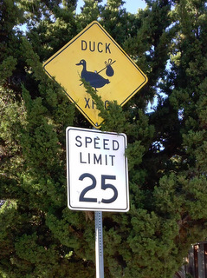
FUN FACT: John sometimes trims bushes that block his neighborhood signage…
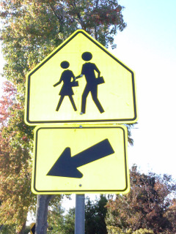
A 19 MPH which was stolen was replaced with this sign;
which actually allowed people to drive faster; making the street less safe…
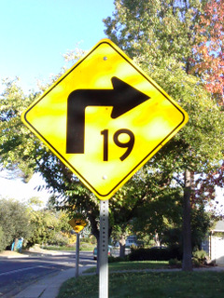
ALMOST NO ONE drives 19 MPH on this stretch of Dunford Way!?!

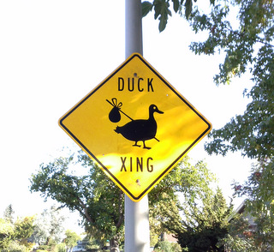
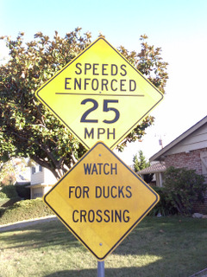
25 MPH enforced? Once again; I don't think so…

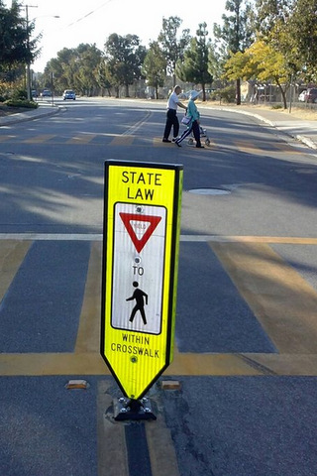
John is largely responsible for the placement of this state law crosswalk sign on Dunford Way…

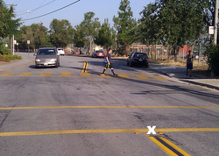
This same state law crosswalk sign was missing for about one year before being replaced due to Johns' continuous efforts; even though it is right by a school where many students cross…

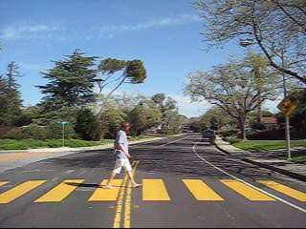
This Abbey Road-style crosswalk on Dunford Way was installed because of Johns' efforts;
as well as another crosswalk partially seen to the left. But after trying for many years; no much-needed state-law crosswalk sign has yet been installed at this sometimes dangerous intersection…

SEE: STATE LAW CROSSWALK SIGNS NEEDED NOW! @ http://www.youtube.com/watch?v=CEw0U15oaMQ

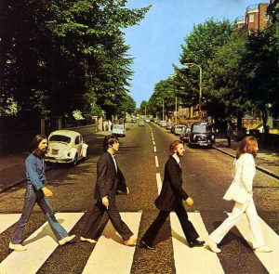
John Lennons' mother was run over by a policeman when he was 9 years old…

LIFE OR COMMERCE? > The crosswalk seen on the front cover of the Beatles album "Abbey Road" was the result of a national debate in the UK regarding pedestrian safety -- What is more important? Life or commerce? I think we ALL know the answer to that one…

